SHEET 1 - Sem 1 Exam Prep
SECTION 1: CALCULATOR FREE
1. | [4 marks: 1 mark each]
Write the following scales as a ratio in its simplest form, without the units.

a) 5cm : 1m b) 2mm : 20m

1:20 1:10000

c) 0.5cm : 4km d) 1m : 0.55km

1:800000 1:550

2. | [1 mark]
Circle the correct answer.
What is the enlargement factor?
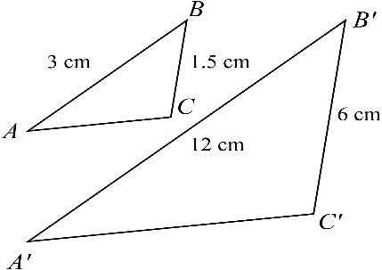

NOT TO
SCALE
a) 2 b) 4 c) 3 d) 6

3. [1 mark]
Circle the correct response.
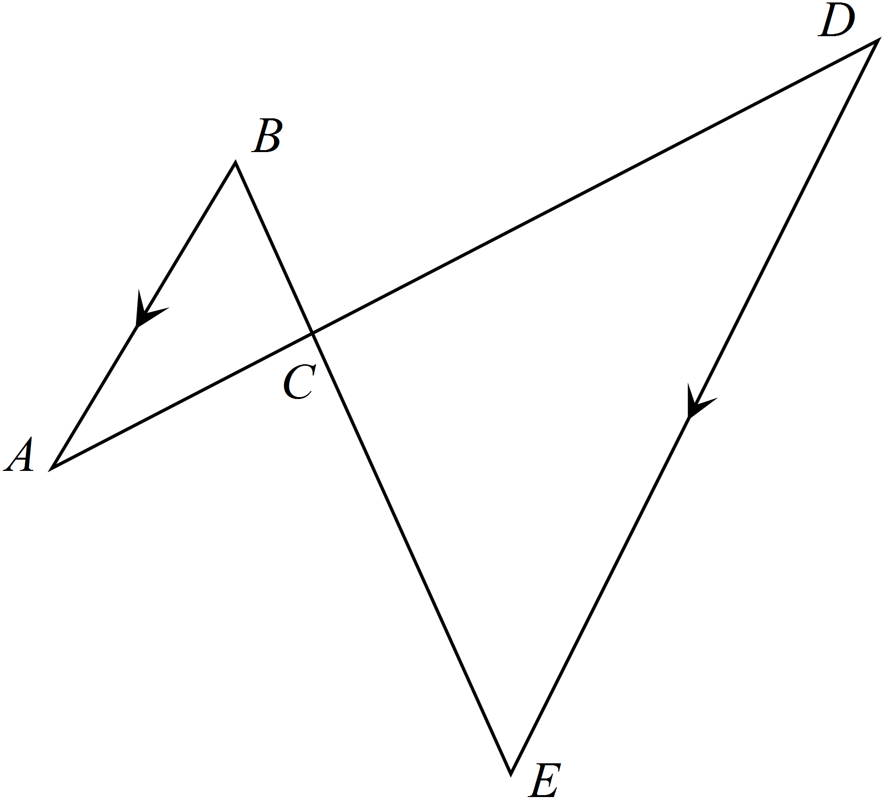

Which of the following reasons could be used to prove that?

a) The three corresponding sides of the triangles are in the same ratio.

b) The three corresponding angles of the triangles are in the same ratio

c) The three corresponding angles of the triangles are equal.

d) Two corresponding sides of the triangles are in the same ratio and the included angle is equal.

4. [2 marks]
Rebecca prints out a square photograph, then decides that she likes it so much she wants frame it. She
needs to enlarge the photo to four times the original size. If the area of the original photograph was
100 cm². What is the area of the enlarged photograph?

10cm 10 x 4 = 40cm

10cm = Area = 40 x 40
= 1600cm²

10 x 4 = 40cm

5. [4 marks; 1 mark each]
Use Matrix A below to answer the following question;

Matrix A = 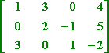

- How many elements are there in Matrix A? 12

- What is the order of Matrix A? 3 x 4

- Is Matrix A a square matrix? no

- What is the value of element a₁₃ ? 0

SECTION 2: CALCULATOR ASSUMED
6. [8 marks:2, 2, 2, 2]
Use the matrices below to answer the following matrix calculations if they are possible, if they are
not give your reason;

A = $\left[\begin{matrix}-15 & 6 \\ 8 & 21\end{matrix}\right]$ B = $\left[\begin{matrix}0.5 & -1.6 \\ 2.3 & 10.2\end{matrix}\right]$ C = $\left[\begin{matrix}112 & 365 95 \\ 215 & 95 45\end{matrix}\right]$ D = $\left[\begin{aligned}\begin{matrix}25 & 0.5 \\ 2 & 35\end{matrix} \\ 4 -5\end{aligned}\right]$

- AD Impossible as the number or columns of a is different to the number of rows of D

- 2B² 2 x B x B =

2 x $\left[\begin{matrix}0.5 & -1.6 \\ 2.3 & 10.2\end{matrix}\right] x \left[\begin{matrix}0.5 & -1.6 \\ 2.3 & 10.2\end{matrix}\right]=2 x\left[\begin{aligned}-3.43 -17.12 \\ 24.62 100.36\end{aligned}\right]$ = $\left[\begin{matrix}-6.86 & -34.24 \\ 49.22 & 200.72\end{matrix}\right]$

- 4A + B

4 x $\left[\begin{matrix}-15 & 6 \\ 8 & 21\end{matrix}\right]$ + $\left[\begin{matrix}0.5 & -1.6 \\ 2.3 & 10.2\end{matrix}\right] =$ $\left[\begin{matrix}4 x-15+0.5 & 4 x 6+-1.6 \\ 4 x 8+2.3 & 4 x 21+10.2\end{matrix}\right]$= $\left[\begin{matrix}-59.5 & 22.4 \\ 34.3 & 94.2\end{matrix}\right]$

- 2CD

2 x $\left[\begin{matrix}112 & 365 95 \\ 215 & 95 45\end{matrix}\right]$ x $\left[\begin{aligned}\begin{matrix}25 & 0.5 \\ 2 & 35\end{matrix} \\ 4 -5\end{aligned}\right]$ = $\left[\begin{matrix}7820 & 24712 \\ 11490 & 6415\end{matrix}\right]$

7. [2 marks]
Two rectangles are similar. The smaller rectangle has sides 12 cm and 7 cm. The longer side of
the larger rectangle is 30 cm. How long is it’s shorter side? (Hint: Draw a diagram)

12cm 30cm

7cm xcm SF = 30/12 = 2.5
x = 2.5 x 7 = 17.5

8. [2marks]
The plan of a building is drawn to a ratio of 1:20. If the width of the building on the plan is 205 cm,
what is the width of the actual building?

1:20 actual size = 20 x 205cm = 4100cm = 41m

9. [4 marks:1, 1, 2]
Use the Diagrams below to answer the following questions.
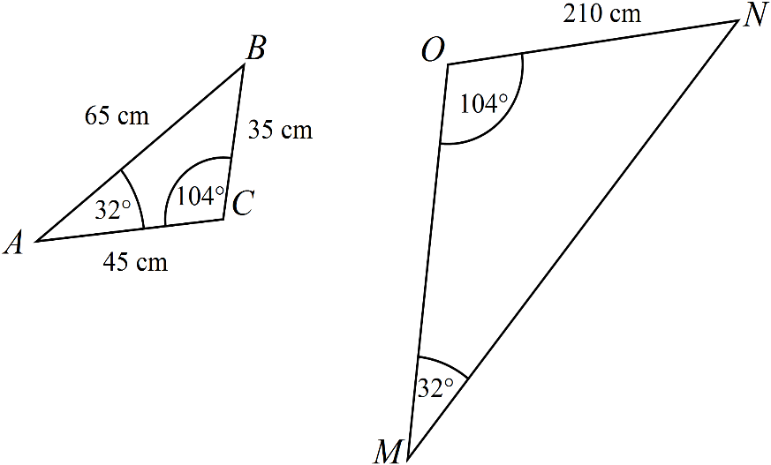

- What similarity rule can be used to prove is similar to ?

AAA

- What scale factor was used to draw?

6

- Given this scale factor, what are the lengths of the remaining two sides of ?

65 x 6 = 390 , 45 x 6 = 270

SHEET 2- Sem 1 Exam Prep
SECTION 1: CALCULATOR FREE
1. [8 marks; 1,1,1,2, 3]
Answer the following given that;
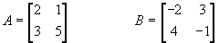

- A + B A + B = $\left[\begin{matrix}2+-2 & 1+3 \\ 3+4 & 5+ -1\end{matrix}\right]$ = $\left[\begin{matrix}0 & 4 \\ 7 & 4\end{matrix}\right]$

- A – B A – B = $\left[\begin{matrix}2- -2 & 1-3 \\ 3-4 & 5--1\end{matrix}\right]$ = $\left[\begin{matrix}4 & -2 \\ 1 & 6\end{matrix}\right]$

- 2A 2A = 2 x $\left[\begin{matrix}2 & 1 \\ 3 & 5\end{matrix}\right]$ = $\left[\begin{matrix}2 x 2 & 2 x 1 \\ 2 x 3 & 2 x 5\end{matrix}\right]$ = $\left[\begin{matrix}4 & 2 \\ 6 & 10\end{matrix}\right]$

- AB A x B = $\left[\begin{matrix}2 & 1 \\ 3 & 5\end{matrix}\right] x \left[\begin{matrix}-2 & 3 \\ 4 & -1\end{matrix}\right]$ = $\left[\begin{matrix}2x-2+1x4 & 2x3+1x-1 \\ 3x-2+5x4 & 3x3+5x-1\end{matrix}\right]$ = $\left[\begin{matrix}0 & 5 \\ 14 & 4\end{matrix}\right]$

- e) 3A + AB 3A = 3 x $\left[\begin{matrix}2 & 1 \\ 3 & 5\end{matrix}\right]$ + $\left[\begin{matrix}0 & 5 \\ 14 & 4\end{matrix}\right]$= $\left[\begin{matrix}3 x 2 & 3 x 1 \\ 3 x 3 & 3 x 5\end{matrix}\right]$ + $\left[\begin{matrix}0 & 5 \\ 14 & 4\end{matrix}\right]$= $\left[\begin{matrix}6 & 3 \\ 9 & 15\end{matrix}\right]+\left[\begin{matrix}0 & 5 \\ 14 & 4\end{matrix}\right]$=

= $\left[\begin{matrix}6+0 & 3+5 \\ 9+14 & 15+4\end{matrix}\right]$ = $\left[\begin{matrix}6 & 8 \\ 23 & 19\end{matrix}\right]$

SECTION 2: CALCULATOR ASSUMED
2. [5 marks: 2, 1, 1, 1 ]
The following table shows the number of first, second and third places that five competing
athletes gained, at a recent athletics carnival.

 | 1st | 2nd | 3rd
Zane | 2 | 1 | 3
Michael | 1 | 0 | 4
Daniel | 0 | 5 | 2
Matthew | 2 | 2 | 2
Benjamin | 3 | 0 | 4

- Construct a 5 x 3 matrix to represent these results and call it Matrix A.

Matrix A = $\left[\begin{aligned}\begin{matrix}2 & 1 3 \\ 1 & 0 4\end{matrix} \\ 0 5 2 \\ 2 2 2 \\ 3 0 4\end{aligned}\right]$

- If athletes were awarded 5 points for 1st place, 3 points for a 2nd place and 1 point for a 3rd place construct a 3 element column matrix and call it Matrix B.

Matrix B = $\left[ \begin{aligned}\begin{matrix}5 \\ 3\end{matrix} \\ 1 \end{aligned}\right]$

- Using the matrices A and B calculate the total points received by each athlete.

$\left[\begin{aligned}\begin{matrix}2 & 1 3 \\ 1 & 0 4\end{matrix} \\ 0 5 2 \\ 2 2 2 \\ 3 0 4\end{aligned}\right]$ x $\left[ \begin{aligned}\begin{matrix}5 \\ 3\end{matrix} \\ 1 \end{aligned}\right]$ = $\left[\begin{aligned}16 \\ 9 \\ 17 \\ 18 \\ 19\end{aligned}\right]$

- An award is given to the athlete who earns the most points during the meet. Who of the 5 athletes won the award?

Benjamin

3. [8 marks: 2, 2, 4]
Use the following floor plan to answer the questions below given that it has been drawn to the following scale 1: 1500.

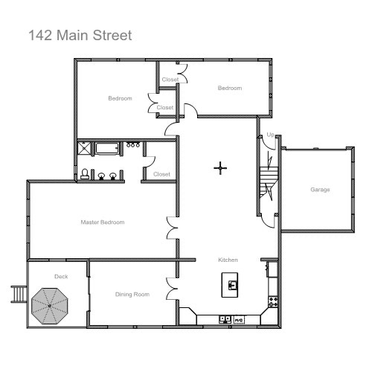
- What are the dimensions of the garage?

Need to measure dimensions then use the scale 1:1500 eg: (30mm – 32mm x 34mm – 36mm)

- What would be the area of the deck in real life?

Area = Length x width measured then changed into m² using the scale 1²:1500²

- If all of the bedrooms, including the closets, are to be carpeted, what is the total amount of carpet needed in square metres?

Combined Area = 3 x rectangular rooms + the main closet changing all measurements into m using the scale 1²:1500²
Note: they can convert the measurements first using the scale 1:1500 or at the end using 1unit²: 1500² I gave 2mm either side of my measurements for accuracy as some students used the inside of the room for dimensions.

